HACKUP TECHNOLOGY PVT. LTD.
AI-Powered SOC & Digital Forensics Internship

MINI PROJECT – 4 Attack Detection

Name | S ABIRAMI
College | Subbalakshmi Lakshmipathy College of Science
Department | Computer Science (Security System Specialization)
Year | II
Week | Week 2 — SIEM and Threat Detection
Tool Used | Wazuh SIEM Dashboard
Platform | Kali Linux on VirtualBox
Attack Simulated | SSH Brute-Force (Invalid User Login)
Submitted To | Hackup Technology Pvt. Ltd.

1. Introduction
This report documents the completion of Mini Project 4 as part of the Week 2 module on SIEM and Threat Detection during the AI-Powered SOC & Digital Forensics Internship at Hackup Technology Pvt. Ltd.
A brute-force attack is one of the most common cyber threats faced by organizations. In this type of attack, an adversary repeatedly tries different credentials to gain unauthorized access to a system. Detecting such attacks in real time is a core responsibility of a Security Operations Center (SOC) analyst.
In this project, a brute-force SSH attack was simulated against the local system, and the Wazuh SIEM was used to detect the attack patterns, generate alerts, and produce a structured incident report — demonstrating the complete attack detection workflow used in real SOC environments.

2. Objectives
- Simulate a brute-force SSH attack using repeated failed login attempts
- Detect attack patterns using the Wazuh SIEM dashboard
- Analyze generated alerts and classify them using MITRE ATT&CK framework
- Generate a structured incident report documenting findings and response actions

3. Attack Scenario

3.1 Attack Type
Parameter | Value
Attack Type | SSH Brute-Force Attack
Attack Vector | Network (SSH Protocol)
Target System | 10.0.2.15 (Kali Linux VM)
Attacker | Same machine (simulated)
Target Account | fakeuser (non-existent account)
Port | 22 (SSH)
MITRE ATT&CK Technique | T1110 — Brute Force
MITRE Sub-Technique | T1110.001 — Password Guessing

3.2 Attack Simulation Method
The attack was simulated by repeatedly attempting SSH connections to the target system using a non-existent username ('fakeuser') with incorrect passwords. This mimics a real-world credential stuffing or brute-force attack scenario.
ssh fakeuser@10.0.2.15 # Executed 5+ times with wrong passwords
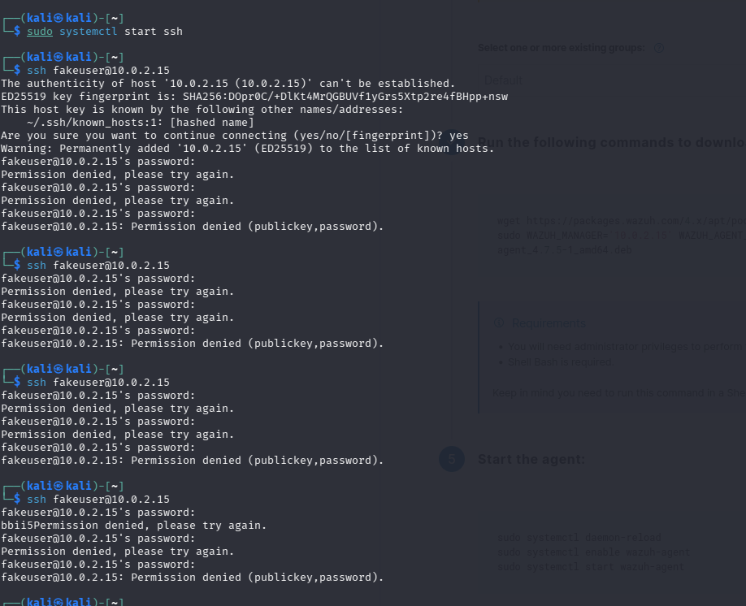

Figure 1: Simulated brute-force SSH attack showing repeated authentication failures

4. Detection Analysis

4.1 Alert Detection in Log File
Wazuh immediately detected the failed authentication attempts and logged them as security alerts. The following command was used to verify detection:
sudo grep -i "authentication_failed|invalid user" /var/ossec/logs/alerts/alerts.log | tail -20
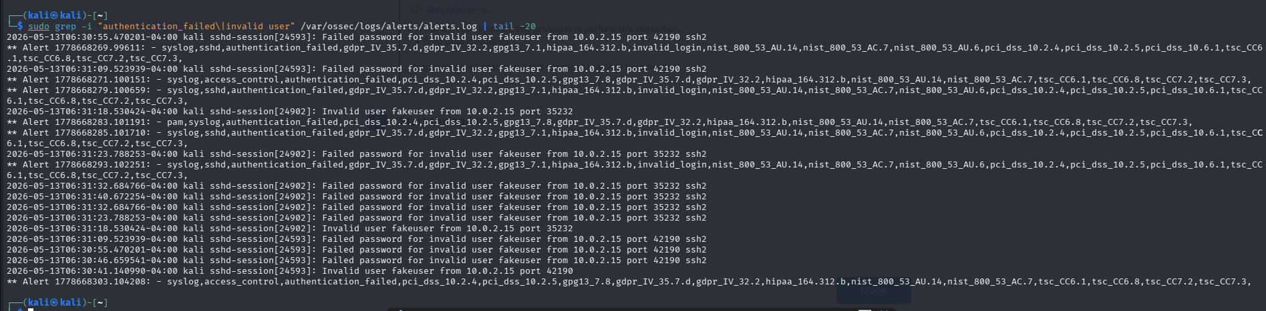
Figure 2: Wazuh alert log confirming brute-force detection with compliance framework tags

4.2 Dashboard Alert Statistics
The Wazuh Security Events dashboard was accessed to view a visual summary of all detected alerts over the past 24 hours. The dashboard showed the following key metrics:
Metric | Value | Significance
Total Alerts | 141 | All security events detected in 24 hours
Authentication Failures | 24 | Direct result of brute-force simulation
Authentication Successes | 14 | Legitimate login sessions
Level 12+ Alerts | 0 | No critical severity events
Top Attack Technique | Password Guessing | MITRE ATT&CK T1110.001

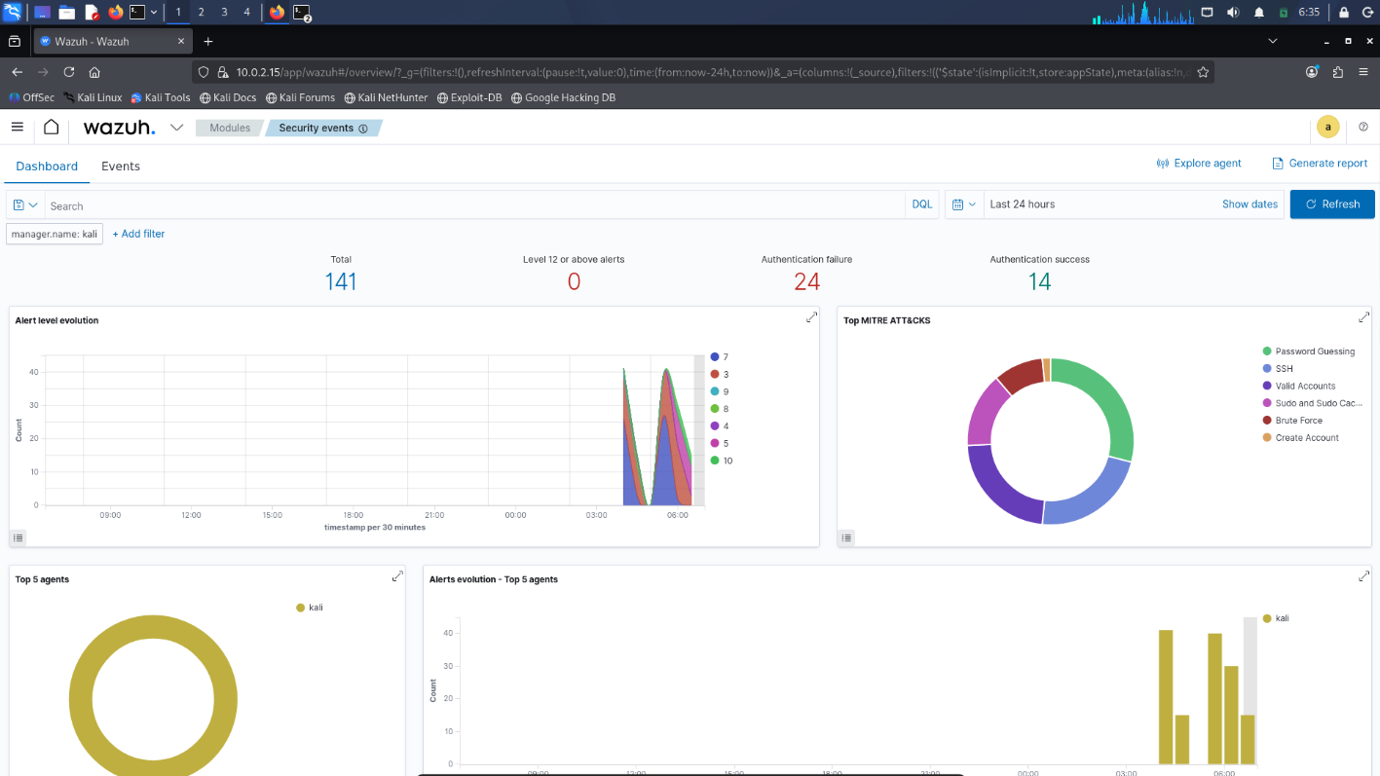

Figure 3: Wazuh Security Events Dashboard showing complete attack detection statistics

4.3 MITRE ATT&CK Classification
The Wazuh dashboard automatically classified the detected attack techniques using the MITRE ATT&CK framework. The Top MITRE ATT&CKS chart displayed the following threat categories:
MITRE Technique | Category | Detection Count
Password Guessing | Credential Access | Highest
SSH | Lateral Movement | High
Valid Accounts | Defense Evasion | Medium
Sudo and Sudo Caching | Privilege Escalation | Medium
Brute Force | Credential Access | Medium
Create Account | Persistence | Low
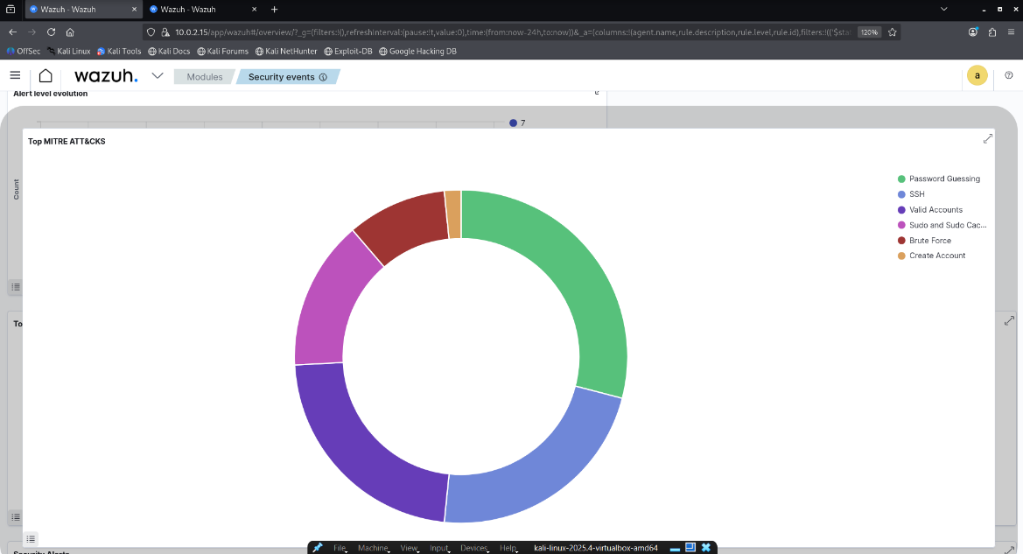

Figure 4: MITRE ATT&CK framework classification of detected attack techniques

4.4 Alert Level Evolution
The Alert Level Evolution chart in the Wazuh dashboard displayed a clear spike in security alerts at the time of the brute-force simulation, providing visual evidence of the attack timeline.
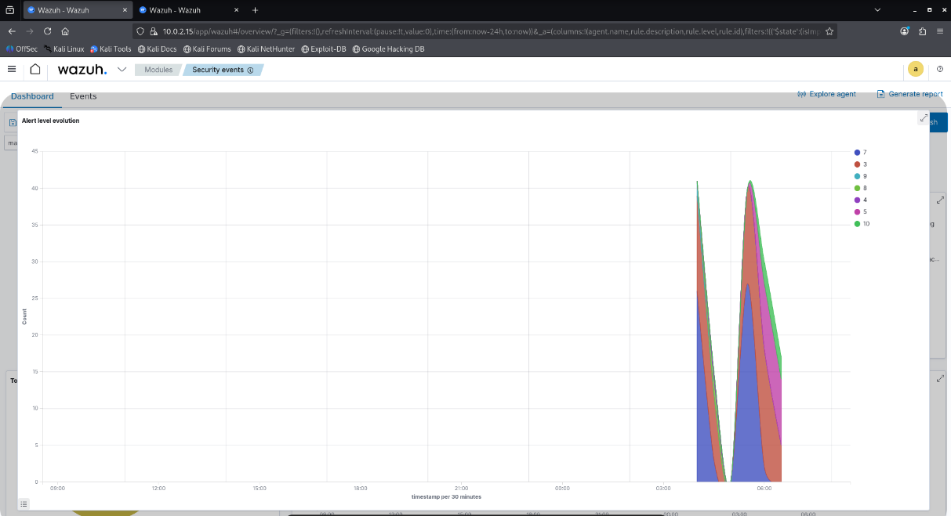

Figure 5: Alert Level Evolution chart showing spike in alerts during brute-force attack simulation

5. Incident Timeline
Time | Event | Detection Status
06:18 (approx) | SSH server started on target | N/A
06:20 | First failed SSH login attempt — fakeuser | Detected
06:20-06:31 | Repeated failed SSH attempts (5+ times) | Detected
06:31 | Wazuh generates authentication_failed alerts | Alerted
06:31 | MITRE ATT&CK classification applied automatically | Classified
06:35 | Dashboard shows 24 Authentication Failures | Reported
06:35 | Incident report generated from dashboard | Documented

6. Incident Report

6.1 Incident Summary
Field | Details
Incident ID | INC-2026-001
Incident Type | Brute-Force Authentication Attack
Severity | Medium
Status | Detected & documented
Source IP | 10.0.2.15
Target IP | 10.0.2.15
Target Service | SSH (Port 22)
Target Account | fakeuser (non-existent)
Detection Tool | Wazuh SIEM 4.7.5
Total Alerts Generated | 24 Authentication Failures

6.2 Findings
- Wazuh successfully detected all SSH brute-force attempts in real time
- 24 authentication failure alerts were generated and logged
- Alerts were automatically mapped to MITRE ATT&CK T1110 (Brute Force)
- Compliance frameworks (GDPR, HIPAA, PCI-DSS, NIST 800-53) were tagged automatically
- The Alert Level Evolution chart showed a clear visual spike during the attack
- No successful unauthorized login was achieved — attack was unsuccessful

6.3 Recommended Response Actions
- Block the source IP using firewall rules if attack originates externally
- Implement account lockout policy after 3-5 failed attempts
- Enable Multi-Factor Authentication (MFA) for SSH access
- Configure Wazuh active response to automatically block brute-force IPs
- Review SSH configuration to disable password authentication and use key-based auth
- Set up email notifications for high-volume authentication failure alerts
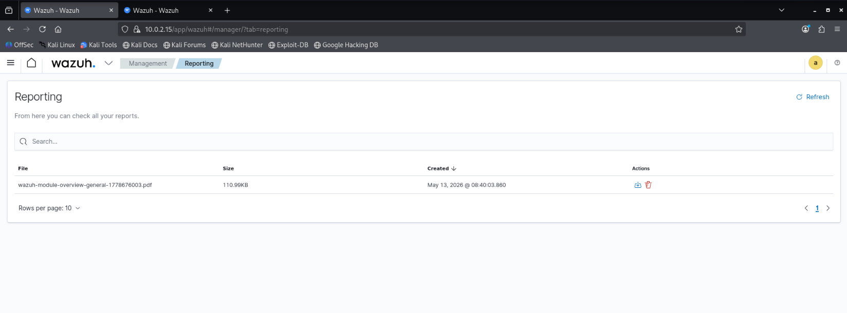

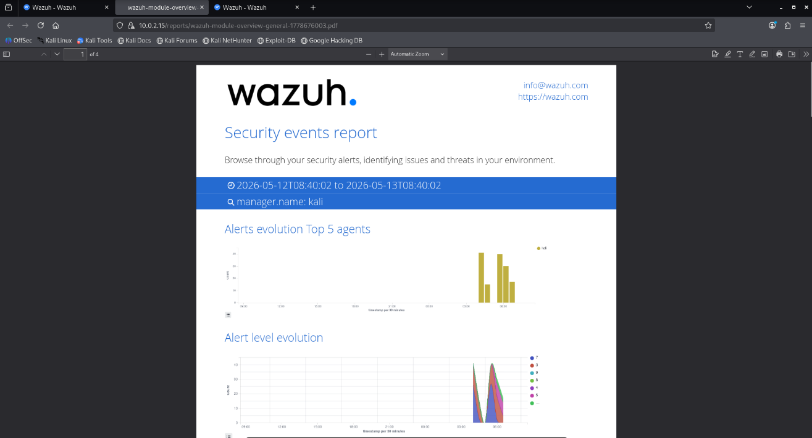

Figure 6: Wazuh auto-generated incident report from Security Events dashboard

7. Conclusion
Mini Project 4 was completed successfully. A brute-force SSH attack was simulated and detected in real time using the Wazuh SIEM platform. The dashboard clearly showed 24 authentication failures, automatic MITRE ATT&CK classification, and visual alert evolution charts.
This project demonstrated the critical role of SIEM systems in detecting credential-based attacks. In a real SOC environment, such detections would trigger immediate response actions including IP blocking, account lockout, and escalation to Tier 2 analysts.
The combination of log-based detection, visual dashboards, and automated compliance mapping makes Wazuh a powerful and practical tool for SOC operations — providing the foundational skills required for a career in cybersecurity.

